Listening
1 [1.06] Read the statements. Then listen to a radio show about future predictions and say if the statements are true or false. (10 marks)
1 Ian Tucker is an engineer. _______
2 Ian says in the future we might be able to use our minds to talk to each other. _______
3 The communication would be as words instead of electronic signals. _______
4 Ian thinks that in the future we will live forever. _______
5 The technology to allow us to live longer won’t cost very much money. _______
6 Scientists in the UK are exploring how to change the Earth’s climate. _______
7 The scientists aim to protect our planet. _______
8 By 2025, Ian predicts people will use machines to help their brains work faster. _______
9 Ian thinks only a few people will have access to these machines by 2075. _______
10 Listeners can contribute more ideas via social media. _______

Vocabulary
2 Complete the sentences with the phrases in the box. (5 marks)
get a driving licence get married get old
take some time out take up
1 I always make sure I ______________________ when I need a rest.
2 It’s common for people in the UK to ______________________ and settle down in their thirties.
3 In the UK, you can ______________________ at the age of seventeen.
4 I want to travel the world and have fun before I ______________________.
5 You’re never too old to ______________________ a new sport.

3 Choose the correct words or phrases.
(10 marks)
1 It’s never too late to get a phone / hobby / pension and learn something new.
2 I’m going to get old / travel around / get involved in Australia and learn how to surf.
3 It’s a good idea to waste / spend / earn some time abroad while you’re young.
4 My sister wants to start / get / take up her own business after she gets her degree.
5 Most people get a pension / bank account / job when they retire.
6 When I leave school, I want to get a hobby / job / bank account as a chef.
7 I think it’s important to look after / get involved / settle down yourself and eat healthily.
8 When I get a degree / driving licence / family, I’ll be able to visit more local places.
9 He’s going to tie himself down / settle down / retire young and travel the world.
10 I’d like to get involved with a charity / have a family / have fun to help others.

Language focus
4 Complete the first conditional sentences with the correct form of the words and phrases in the box. (10 marks)
not get rich not look
not get married live not get a driving licence
1 People ______________________ on other planets if there is an epidemic on Earth.
2 I ______________________ unless I meet the right person.
3 Unless I have some lessons, I ________________________________.
4 You ______________________ unless you get a job.
5 Humans ______________________ the same if they adapt to conditions on another planet.
5 Complete the sentences with the correct form of will, might or be going to and the verb in brackets. (5 marks)
1 If you don’t study, you ______________________ go to university. (not be able to)
2 Which cities ______________________ you ______________________ on your next trip? (visit)
3 Unless a catastrophe hits the planet, we ______________________ to survive and grow. (continue)
4 When I’m older, I ______________________ my own business. (start up)
5 I’ve decided that I ______________________ (teach) myself how to play the guitar.
6 Write complete questions or sentences with the words below. Use will or be going to. (10 marks)
1 you / wear / new shirt / tonight / ?
______________________________________
2 in ten years’ time / I / live / abroad
______________________________________
3 we / watch / the football match / on Sunday
______________________________________
4 he / have / pizza / for dinner
______________________________________
5 they / go / supermarket / this afternoon
______________________________________
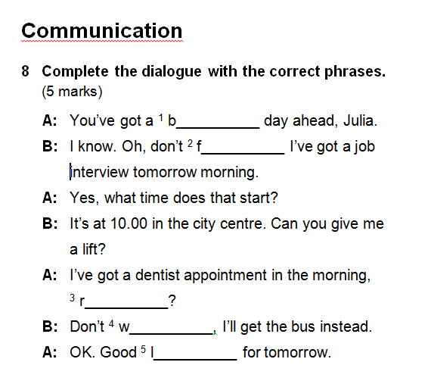

Reading
Who do you think you’ll be?
What do you think you’ll be doing in the future? Are you going to travel the world or maybe start up a business? Tell us about your goals for the future!
Thomas
I see myself finishing university and taking some time out. I’m going to travel around Australia. Unless you travel, you won’t get a chance to gain different life experiences. I’m going to have fun!
Lucia
I always wanted to travel into space, and now I think it may be a possibility in the future. Some scientists believe we’ll be living on other planets in a decade or two.
Marcus
I’m going to start my own business and make my first million before I’m thirty! Then I’ll retire young and enjoy life. I’ll settle down and start a family. I can’t wait!
Debbie
I’ve been thinking a lot about the future. I’ll be studying at university for three years and after that, I’d like to do some volunteering at a school in India.
Julia
I’m just a student now, but I’ve got some big plans for the future. I’ve started teaching myself to play the guitar so I can play in a successful rock band. Why waste time working all your life?
7 Read the text. Then read the sentences and write true or false. (10 marks)
1 Thomas is going to travel after university. _______
2 He wants to settle down soon. _______
3 Lucia thinks she won’t travel into space. _______
4 She says scientists believe we’ll be living on other planets in a year or two. _______
5 By the time he’s thirty, Marcus wants to be rich. _______
6 After he retires, he wants to have children. _______
7 Debbie’s university course is four years long. _______
8 She wants to help people while she’s in India. _______
9 Julia is teaching in a music school. _______
10 She is planning to work hard for many years. _______

Communication
8 Complete the dialogue with the correct phrases. (5 marks)
A: You’ve got a ¹ b__________ day ahead, Julia.
B: I know. Oh, don’t ² f__________ I’ve got a job interview tomorrow morning.
A: Yes, what time does that start?
B: It’s at 10.00 in the city centre. Can you give me a lift?
A: I’ve got a dentist appointment in the morning, ³ r__________?
B: Don’t ⁴ w__________, I’ll get the bus instead.
A: OK. Good ⁵ l__________ for tomorrow.

Writing
9 Write a blog post about a friend’s plans and ambitions for the future. Use the plan in the box to help you. Write 80–100 words. (10 marks)
Paragraph 1
About your friend: their general plans.
Paragraph 2
Career: what job would they like to do?
What are they going to do to achieve their goals?
He / She would like to ... .
Paragraph 3
In twenty years: where do they see themselves?
What do you think they will be doing?
I suppose that … . Who knows … ?
I wonder what … ?

Total marks:
Listening ____ / 10 Vocabulary ____ / 15
Language focus ____ / 25 Reading ____ / 10 Communication ____ / 5 Writing ____ 10
TOTAL ____ / 75

